Year Summary
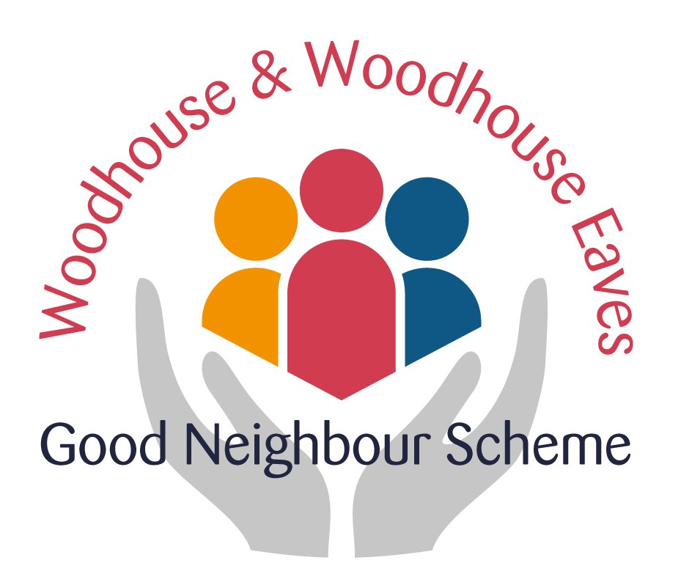
October 2018 to September 2019

Well we are three years old and still growing. Our volunteers are as keen as ever– we now have 39 in total - and since last October we have taken on 530 jobs. As you will see from the pie chart driving is our most frequent request – it is split into lifts to medical appointments and a separate tally shows other driving jobs. The bar chart shows clearly how the number of jobs is increasing year-on-year, as the number of regular users grows steadily.
Our other largest commitment is befriending and Cherrie Whatmuff has produced a Report. Again it is easy to see how much they are undertaking and if anyone feels befriending is something they would like to do, please do talk to the team.
This year we have had to renew our DBS (Disclosure and Barring Services) certificates for which we received a grant from the Leicestershire and Rutland Community Foundation. Sue Young and Lynn Hopkins have made sure that this has gone through smoothly. The good news is that all the present volunteers have signed up for the automatic renewal system, which saves both money and time. We will still have to pay for new volunteers DBS checks.
Just after the last AGM, Tricia Shakespeare organized a Dementia Friends Information Session which was well attended by the volunteers and village and which was most informative.
Graham Cameron attended a Leicestershire Police Fraud & Cyber Protection Conference and reported back to the Steering Group with the details. As a result we sent out a copy of the leaflet entitled It Takes Time -Take Five to Stop and Think and Graham has kindly offered to talk to people individually.
A new Volunteer Handbook has been given to each of our volunteers, as we felt we needed to give clearer instructions and information. The loose-leaf format was a suggestion made on one of the feedback forms at the last AGM.
I have to say that I think The Good Neighbour Scheme is most proud this year for having arranged the Community Fair on 24th March. There were about 500 people who attended on the day, 49 societies and clubs were represented and they were split between the three halls. There were demonstrations in each hall which included Tai Chi, yoga and dancing children’s groups. There was fun and games for the children. The scouts ran a splendid café in the Village Hall. We also gained some new volunteers. Everyone seemed to have fitted in with the spirit of the day and really enjoyed themselves.
We have again been approached by other people who wish to start up Good Neighbour Schemes and a few of our steering group members have attended and spoken at their meetings. Interestingly the new groups have given ideas to us too!
So a big thank you to everyone here tonight who is a volunteer – we could not have reached the magnificent total of over a thousand jobs since we started without your support and enthusiasm.

